**Quiz 1 Answer Guide:**

**1:**

**Answer:-**

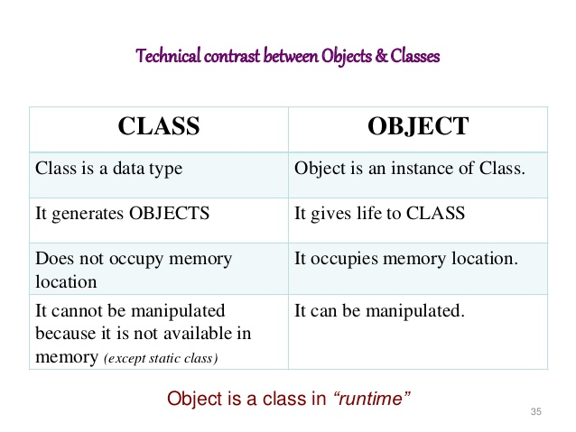

**2:**

**Answer:-**

Using assert() function and check all the preconditions in it.

**3.**

**Answer :-** Big O(n^2)

**4.**

**Answer:-**

public:

throttle::throttle()

{

maxSpeed= 300;

numberofwheels = 4;

}

**5.**

**Answer :-** 42